1. **NodeJS** would be used by the **CLI** behind the scene to bundle and optimize app.
2. **npm:** To manage dependencies  
   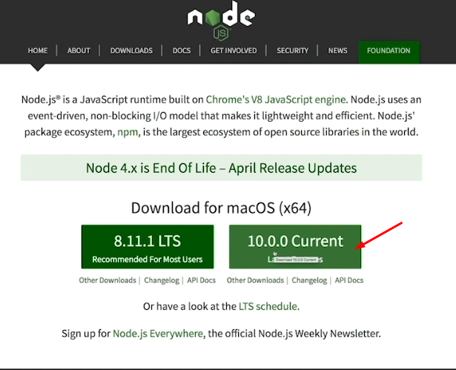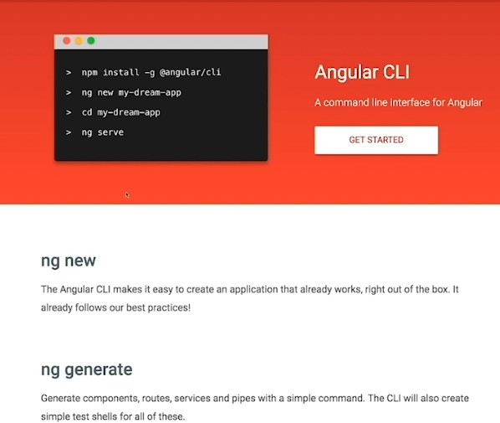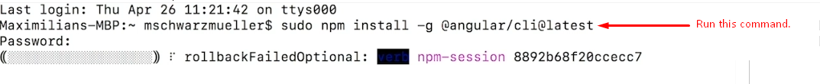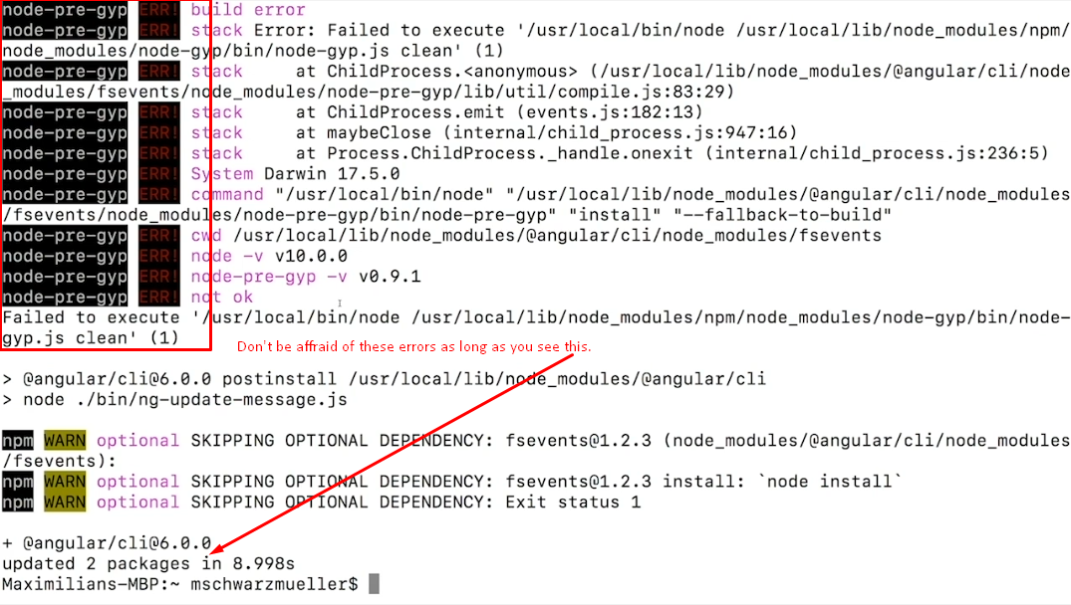  
   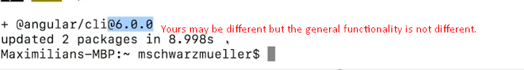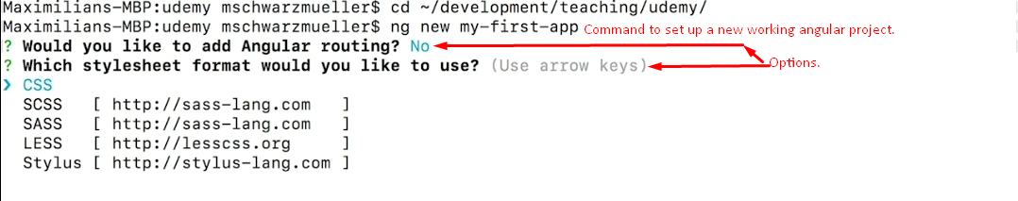
3. 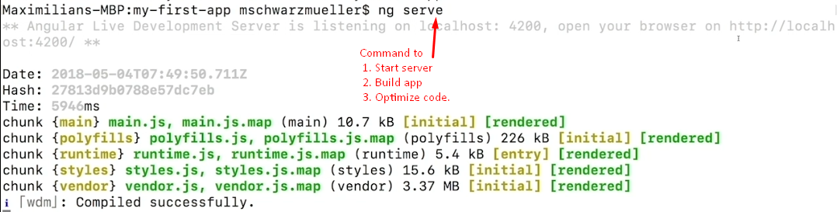
4. 